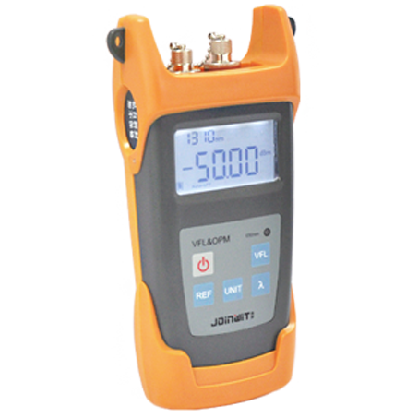
Power Meter and VFL S405
S405 Power meter and VFL integrated in one unit, this tester allows to perform both optical power/loss measurements and fiber faults tracing visually.
Features
S405 power meter and VFL is an ideal tester used in quickly mechanical splicing and FTTx networks.
Optical port: FC, SC interchangeable supports various optical connectors.
Applications
Maintenance in Telecom
Maintenance CATV
Fiber Optic Lab Testing
Other Fiber Optic Measurements
Specifications
Model | S405
Operating wavelength  (Power Meter Module) | 850/1300/1310/1490/1550/1625
Detector Type | InGaAs
Output power (VFL module) | 1mw or 10mw
Power Measurement Range | -70~+6dBm/-50~+26dBm
Uncertainty | ±0.5dB
Resolution | 0.01
Operation temperature | -10~+60 ℃
Storage Temperature | -25~+70℃
Auto-off function | Yes, Auto-off after 10minutes idle time
Battery Life @ OPM | 180 hours
Battery Life @ VFL | 60 hours
Power Supply | 3pcs AA Batteries
Weight | 700g (including batteries)
Size | 192*102*50mm

