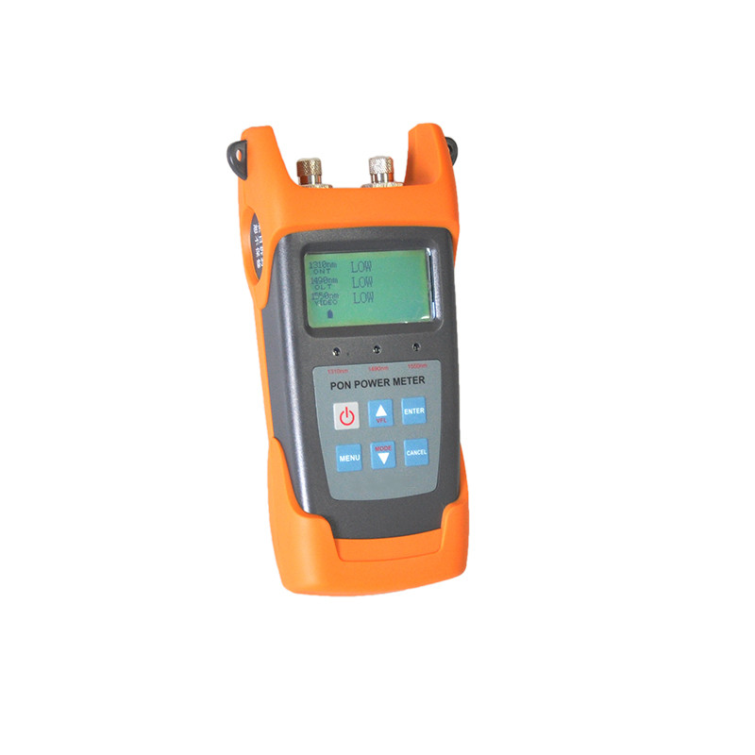
PON Power Meter S316
S316 targets at the FTTx application and maintenance. This PON power meter is able to simultaneously test and estimate the signals of the voice, data and video. It is an essential and ideal tool for the construction and maintenance of the PON projects.
Features
Providing simultaneous measurement at EPON/GPON/GEPON for all three wavelengths on the fiber (1490nm, 1550nm,1310nm )
Used in Burst mode measurement of 1310nm upstream
Convenience for threshold setting, which can set the threshold on the tester
USB communication port enables data transfer to a PC
Offers up to 10 different threshold sets in total
User self-calibration can be retrieved in computer through the software
10 minutes Auto-off function can be activated or deactivated with keypad operation
Specifications
Model | S316
Wavelength | 1310nm | 1490nm | 1550nm
Pass Zone(nm) | 1260～1360 | 1470～1505 | 1535～1570
Isolation (dB) | >40@1490 | >30@1310 | >40@1310
Isolation(dB) | >40@1550 | >40@1559 | >40@1490
Measurement Range(dBm) | -40～+10 | -40～+10 | -40～+20
Measurement Accuracy
Connatural uncertainty(dB) | ±0.5
Linearity(dB) | ±0.1
Passing through insertion Loss(dB) | <1.5
General Information
Detector Type | InGaAs
Optical Connector | FC/SC Interchangeable
Fiber Type | 9/125um
Display | LCD:128*64
Measurement Unit | dB/dBm/xW
Resolution (dB) | 0.01
Power Supply | 3 AA1.5V battery
Operation Temperature (℃) | -10～60
Storage temperature (℃) | -25～70
Dimension(mm) | 200x90x50
Weight(g) | 285

