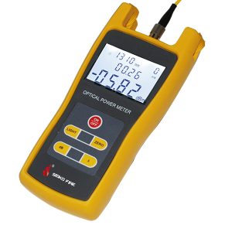
Power Meter S308
S308 handheld optical power meter is a compact and an easy-to-use testing instrument for optical fiber networks, which can be used for absolute optical power measurements as well as for relative loss measurements in optical fibers. It features ingenious appearance, wide range of power measurement, high accuracy and user self-calibration function with high performance-to-price ratio.
Features
User self-calibration function
Comfortable LCD display and optional backlight LCD display supports night operation
Power measurements in dBm or mw and insertion loss in dB
Low battery consumption, more than 240 hours continual operation time for three 1.5V alkaline batteries.
10 minutes Auto-off function can be activated or deactivated.
Applications
Maintenance in Telecom
Maintenance CATV
Fiber Optic Lab Testing
Other Fiber Optic Measurements
Specifications
Type | S308A | S308B
Wavelength (nm) | 800~1700nm
Detector | InGaAs
Measurement Range (dBm) | -70~+3 | -50~+26
Uncertainty | ±5%
Calibrated Wavelength (nm) | 850,980,1300,1310,1490,1550
Resolution (dB) | 0.01
Optical Connector | FC (interchangeable SC, ST)  as well as 2.5mm universal
Power Supply | Alkaline Battery (3 AA 1.5V batteries)
Battery Operating Time | 240 h with 1.5V Battery (3)
Operating Temperature (℃) | -10 ~ +60
Storage Temperature (℃) | -25 ~ +70
Relative Humidity | 0 to 95% (non-condensing)
Dimension (mm) | 175x82x33
Weight (g) | 310
Standard Package
S308 optical power meter,
Protective rubber boot
3pcs 1.5V batteries,
User manual
Cotton swabs and soft carrying case.

