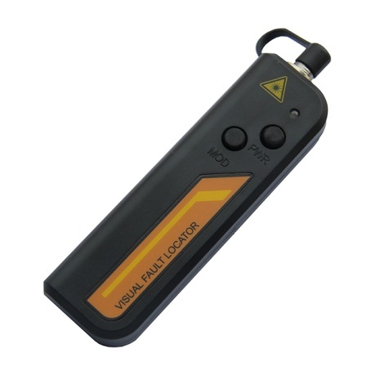
Visual Fault Locator S203
It is one efficient and low-cost basic fiber test tool; it provides a visible way to find fiber faults and identify fibers in an optical network during and after installation.
It includes:
Finding the breakpoint, poor connections, bending or cracking in fiber optic cables.
Finding the faults of OTDR dead zone
End-to-end visual fiber identification
Features
Constant & stable output power
Low battery warning, reminds users to change the battery timely.
Long battery life (up to 40 hours with AAA batteries)
Pocket size and light weight, easy to use.
Re-changeable ceramic tube, to avoid returning to manufacturer for this small fault.
Specifications
Central Wavelength | 650nm±10nm
Emitter Type | FP-LD
Output Power | 1mw or 10mw
Optical Connector | 2.5mm universal connector  For 1.25mm connectors, FC-1.25mm Hybrid adaptor  can be optional on customer requests
Operating Model | Both CW and Pulse(2Hz) available
Power Supply | Two AAA alkaline batteries
Battery Operating Time | 650nm@1mw ≥45hours;650nm@10mw≥15hours  Test with Panasonic LR6 AAA ALKALINE battery
Operating Temperature | -10~+60 (℃)
Storage Temperature | -25~+70 (℃)
Dimension (mm) | 115*45*27
Weight | 50g (without batteries)

